ELEG 309 - Example Problems Chapter 6-1

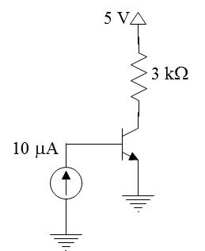**Example 6.1**

An *npn* transistor having *IS* = 10-15 A and ** = 100 is connected as follows: The emitter is grounded, the base is fed with a constant-current source supplying a dc current of 10 A, and the collector is connected to a 5-V dc supply via a resistance *RC* of 3 k. Assuming that the transistor is operating in the active mode, find *VBE* and *VCE.* Use these values to verify active-mode operation. Replace the current source with a resistance connected from the base to the 5-V dc supply. What resistance value is needed to result in the same operating conditions?

**Example 6.2**

The transistor in the circuit 6.14(a) has ** = 100 and exhibits a *vBE* of 0.7 V at *IC* = 1 mA. Design the circuit so that the current of 2 mA flows through the collector and a voltage a +5 V appears at the collector.

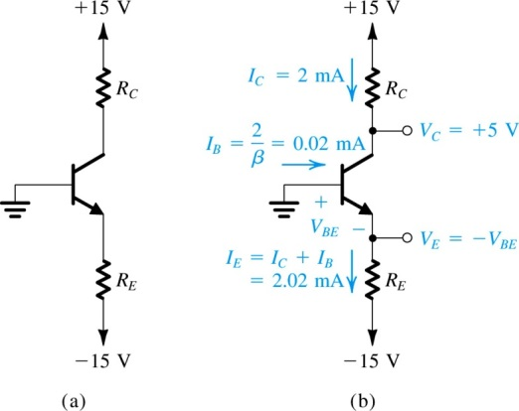

**Exercise 6.13**

In the circuit shown in Fig. E6.13, the voltage at the emitter was measured and found to be -0.7 V. If ** = 50, find *IE, IB, IC,* and *VC*.

**Exercise 6.14**

In the circuit shown in Fig. E6.14, measurement indicates *VB* to be +1.0 V and *VE* to be +1.7 V. What are ** and ** for this transistor? What voltage *VC* do you expect at the collector?



**Example 6.3**

For the circuit in Fig. 6.21, it is required to determine the value of the voltage *VBB* that results in the transistor operating

(a) in the active mode with *VCE=* 5 V

(b) at the edge of saturation

(c) deep in saturation with **forced= 10

For simplicity, assume that *VBE* remains constant at 0.7 V. The transistor ** is specified to be 50.